Report on Evolution and Maintenance of Software - Project
Kaminipaty sai nidhin
19970831-5495
1. Contribution
Sprint 1: Overall contribution is 26%
Week 1(v 36) | - Learned and understood the basic concepts of Angular and Typescript.  - Completed all the necessary installations for the development environment.  - Understood the architecture of the working system.
Week 2(v 37) | Understood the front-end source code with the help of other team members.
Sprint 2: Overall contribution is 23%
Week 3(v 38) | - Understood the concept of code smells, types of code smells, and impact on factors affecting maintainability.  - Identified code smells in Specmate front- end using SonarQube along with other members in the group.  Identification of bugs/code smells:  - Participated in planning poker to identify the severity of code smell (also participated in the workshop).  - Participated in Identifying the type of code smell.
Week 4(v 39) | Refactoring:  Among 3 assigned code smells (2 medium and 1 small) contributed in refactoring the “Getter – global”.
Sprint 3: Overall contribution is 25%
Week 5(v 40) | - Analyzed the impact of improved code on maintainability with the teammates.  - Worked on mocha JavaScript test framework and tried to write test scripts.
Week 6(v 41) | Worked on Feature 7 variant 1: Added static background image to the Specmate login page.
Sprint 4: Overall contribution is 22%
Week 7(v 42) | Participated in final presentation.
Week 8(v 43) | Writing the Report (individual & group).
2. Description

Sprint 1
Reflections on comprehensibility of Specmate code o Understanding the code structure of Specmate is time taking process.
- It is very difficult to comprehend the legacy software, comments play a vital role in understanding the code base, in Specmate the comment ratio of the project is very low, this made me difficult to understand the source code.
- As known difficulty in understanding the system increases the cost of maintenance, improving maintainability of the Specmate is harder.

Sprint 2
- Good aspects of specmate o Among many codes smells in general, SonarQube has identified code smells such as unnecessary complexity, long methods, duplicate code, conditional complexity.
o Some code smells like dead code/unreachable code, long parameter list, data class are already taken care of. This indicate Specmate support quality attributes like readability, testability, usability, maintainability...
- Code smells and its implication on maintenance
S.no | Issue | Severity | Implication on maintenance
1 | Object.ts.equals Complexity | Severe | Having long method increases complexity of code and also become difficult for the users to understand the code base which makes bad impact on maintainability.
2 | ChangeFields  Complexity – length | Severe
3 | Return type void Used as parameter to another function (promise.resolve) | Severe | -
4 | Refactor this function so that its implementation doesn't duplicate | Severe | Duplicate code creates confusion to the user, and it also increases complexity which in turn increases analyzability. This makes hard to maintain.
5 | Getter – Global | Medium | Unused code increases complexity of code, decreases the performance.
6 | Arrangement of CSS file - button: focus | Medium | -
7 | Element-tree: CSS | Low | Unnecessary complexity incurs unnecessary maintenance costs and effort.
8 | Font-family | Low
9 | Not used variables | Low
10 | Unnecessary Boolean | Low
11 | String object - string cast | Low
12 | Undefined parameters | Low
13 | Unnecessary cast | Low
14 | Void return | Low

Table 1: Description of severity of smells and impact on maintenance. iii) Code smell assigned for refactoring:
  - Refactor this getter so that it actually refers to the property '_model' (M).
  - Refactor this getter so that it actually refers to the property '_requirement' (M).
The above code smells are reported in code quality analysis tool (SonarQube) as getter function is not correctly referring to the property. But through code review, the getter property is referring to the actual property value in both the cases (a) and (b).
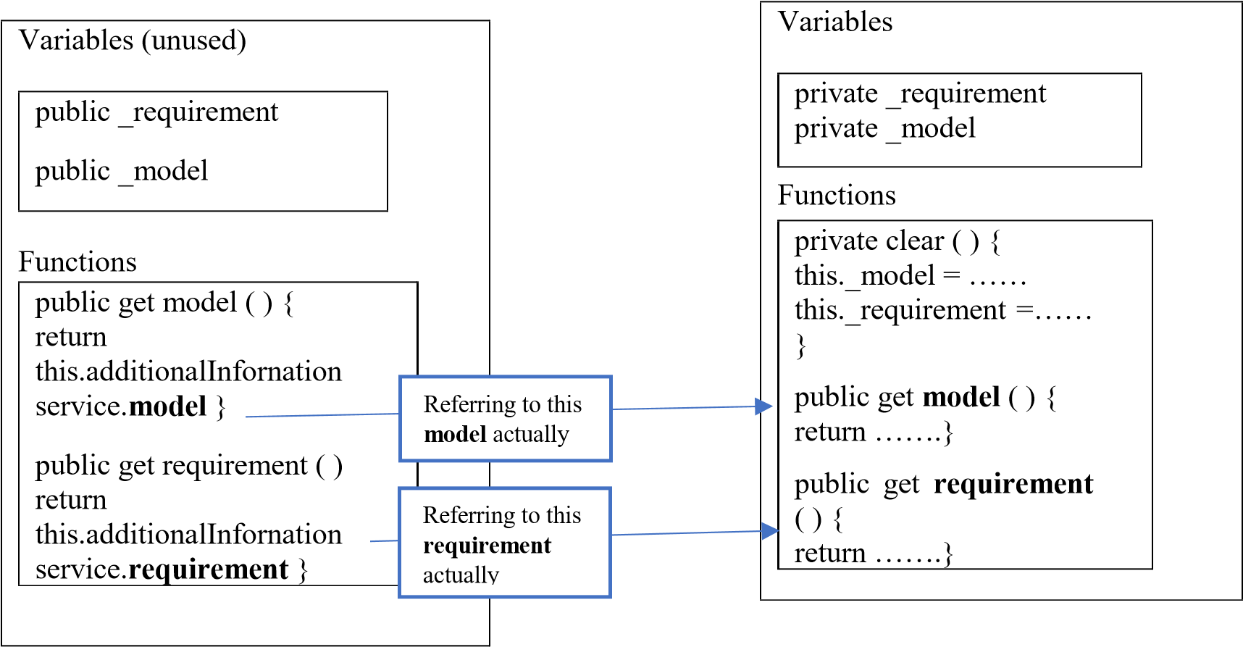
links-actions.component.ts additional-information.service.ts’
This is reported by the SonarQube because the tool analyses the code and compare it with the standard practices. So, when I removed the unused variables from the component ‘linksactions.component.ts, it is no longer shown as code smell in SonarQube.
Later on, we observed that private variables in the ‘additional-information.service.ts’ component were used in a function ‘clear’ which is doing nothing. So, I along with my team decided to delete the function and the variables in that component to improve the quality. Performed static testing technique like peer review and static analysis to ensure that the refactoring works .
Reflections on refactoring :
→ Decreases compilation time.
→ Free up memory space occupied for storing the unused code.
→ Complexity of the code might be reduced.
→ Removing unused or dead code increases performance.
→ Improves readability, later anyone working on the project will not get confused and also no need to understand unused code (saves time and effort).
Impact on maintainability:
Maintainability Factors:
 Reusability
- Analyzability
- Testability
 Modularity
 Modifiability
After modification of code, the complexity of the code might decrease because of removing the unused variables and the dead function, which in return becomes easy to analyze the impact on the system. This means maintainability of the system improves.

Sprint 3&4
- Reflections on the analysability of the Specmate code.
  - Analysability of code strongly depends on how the system is internally structured and also dependency between the components. The structure of Specmate code is well organised to decrease the effort and time of the maintainer.
  - Even though Specmate is well designed, it contains too many components which made difficult to analyse the change impact, this in turn impacts maintainability.

- Feature implementation
The feature assigned to work is Feature 7-variant 1.
Implementation: Added static background image to Specmate login page.
  - We added a static background image to Specmate login page in ‘login.component.ts’ component using AfterViewInit lifecycle hook, which is invoked after angular has fully initialized component’s view, and background will be no longer seen after logging into Specmate. o Drawback: Use of hooks decreases the performance of the system, because hook makes call to all dependency hooks and executes them in the background whenever changes are done. This also increases execution time. o Alternative method: This feature can be implemented without using lifecycle hooks, by adding background image tag in the HTML and CSS login components, which is more maintainable and evolvable. Moreover, this code can also be reused in other components.

